Create a class called Employee that includes three pieces of information as instance variables: first name, last name, and monthly salary. Your class should have a constructor that initializes the three instance variables. Provide a setter and getter method for each instance variable. If the monthly salary is not positive, set it to 0.0. Write a test application named EmployeeTest that demonstrates the Employee class's capabilities. Create two Employee objects and display each object's yearly salary. Then give each Employee a 10% raise and display each Employee's yearly salary again.
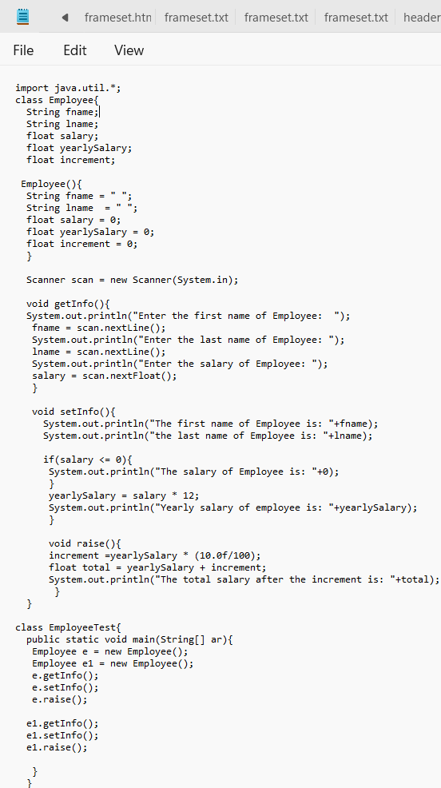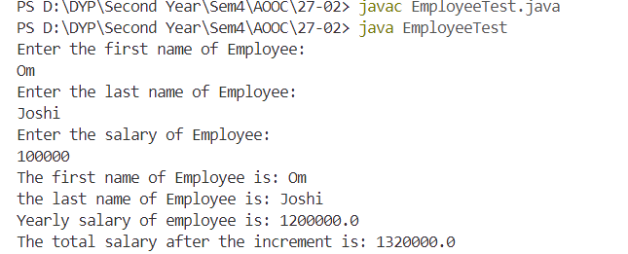

Implement a Java program to print the area of a rectangle by creating a class named 'Area' that has two methods. The first method, named 'setDim', takes the length and breadth of the rectangle as parameters. The second method, named 'getArea', returns the area of the rectangle. The length and breadth of the rectangle are entered through the keyboard.

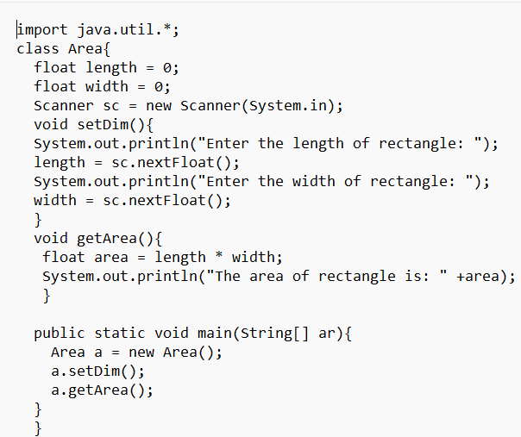
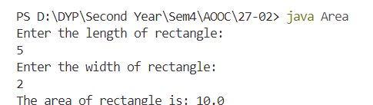

Write a Java program to demonstrate the use of static variables, static blocks, and static methods.
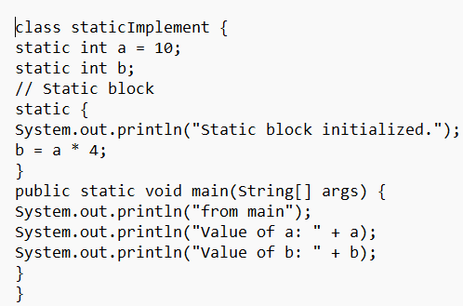
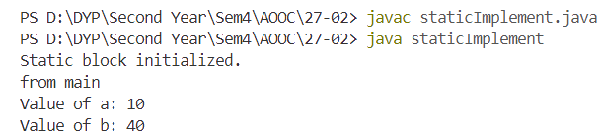

Write a Java program to implement a stack and a queue.
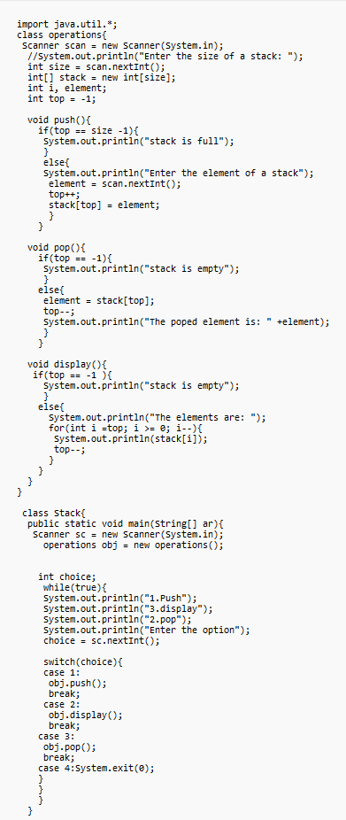
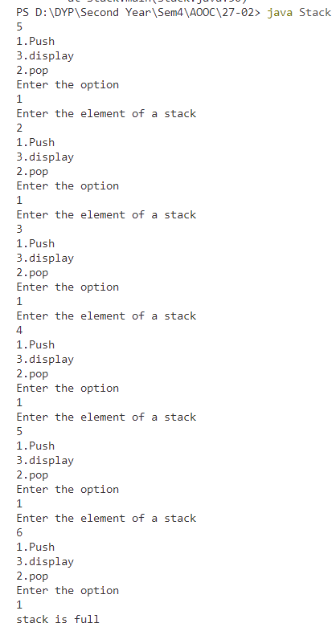

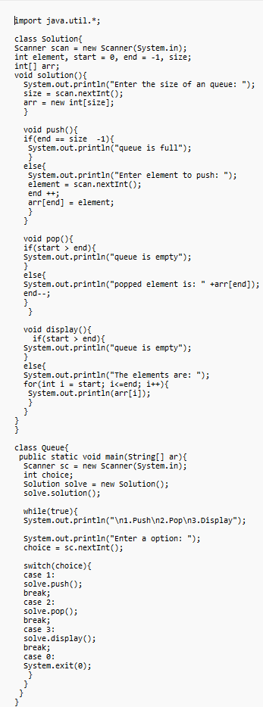
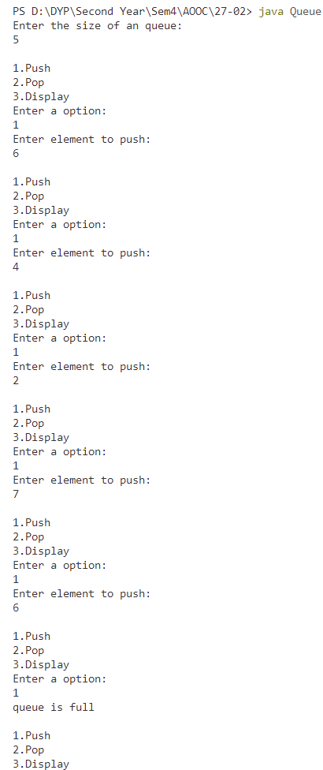
Write a Java program to arrange 10 names in alphabetical order.
